CSE326 : INTERNET PROGRAMMING LABORATORY
CA-1

GROUP MEMBERS :
NAME : Divya Mehrotra
REG. NO. : 12110869
NAME : Sriharsha Maram
REG. NO. :12109074
SECTION : K21ND

PROJECT TITLE:

DESIGN A WEBSITE FOR A
RESTAURANT
INDEX

- Acknowledgement
- About HTML
- About CSS
- Website Screenshots
- Home Page HTML Code
- Home Page CSS Code
- Menu HTML Code
- Menu CSS Code
- Gallery HTML Code
- Gallery CSS Code
- Health Tips HTML Code
- Health Tips CSS Code

ACKNOWLEDGEMENT

We take this opportunity to acknowledge everyone who have helped us in every stage of this project.
Firstly, we are indebtedly grateful to our computer teacher Md. Imran Hussain for his support. We are grateful to our parents and friends for their valuable guidance and support. Without their support this project would not have been completed.
Also, I would like to thank all the faculty members of our college for their kindness and support.

ABOUT HTML

HTML (HyperText Markup Language) is the code that is used to structure a web page and its content. For example, content could be structured within a set of paragraphs, a list of bulleted points, or using images and data tables. As the title suggests, this article will give you a basic understanding of HTML and its functions.
So what is HTML?
HTML is a markup language that defines the structure of your content. HTML consists of a series of elements, which you use to enclose, or wrap, different parts of the content to make it appear a certain way, or act a certain way. The enclosing tags can make a word or image hyperlink to somewhere else, can italicize words, can make the font bigger or smaller, and so on.

ABOUT CSS

Cascading Style Sheets (CSS) is a stylesheet language used to describe the presentation of a document written in HTML or XML (including XML dialects such as SVG, MathML or XHTML). CSS describes how elements should be rendered on screen, on paper, in speech, or on other media.
CSS is among the core languages of the open web and is standardized across Web browsers according to W3C specifications. Previously, development of various parts of CSS specification was done synchronously, which allowed versioning of the latest recommendations. You might have heard about CSS1, CSS2.1, CSS3. However, CSS4 has never become an official version.
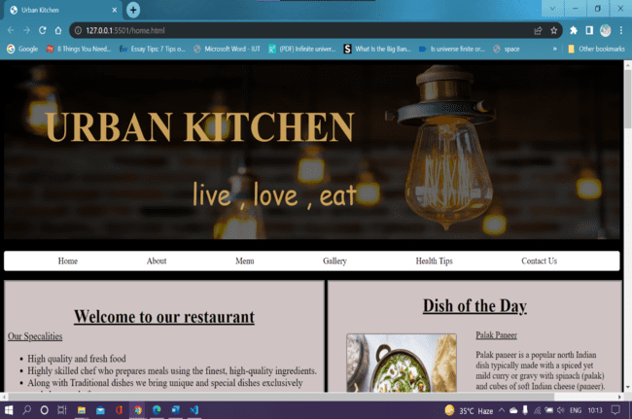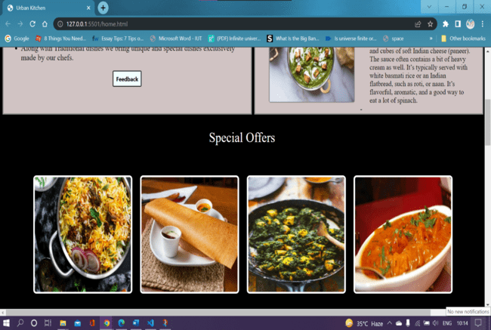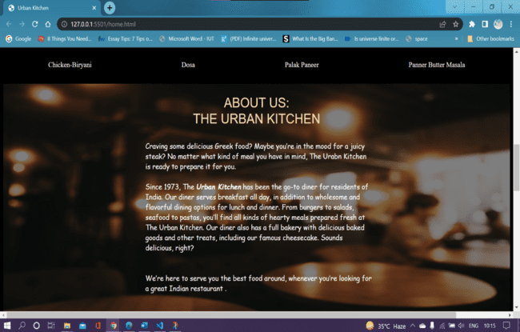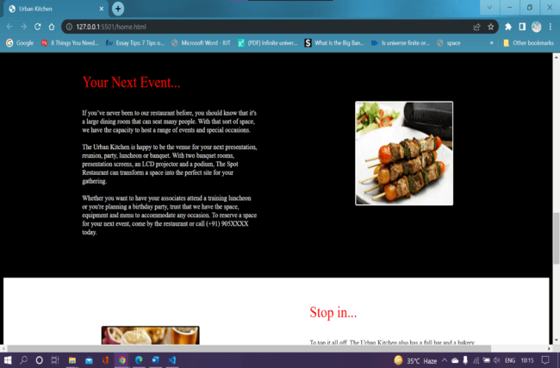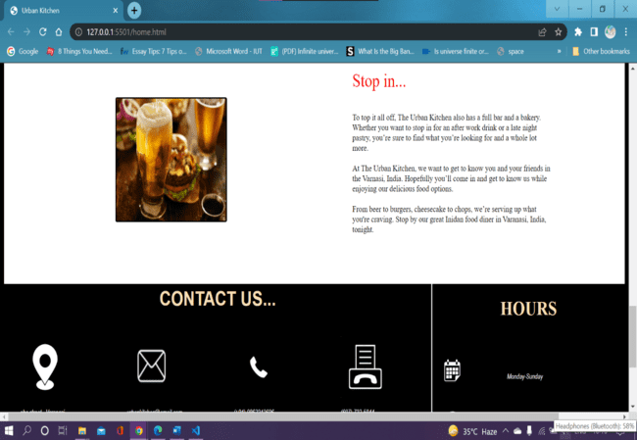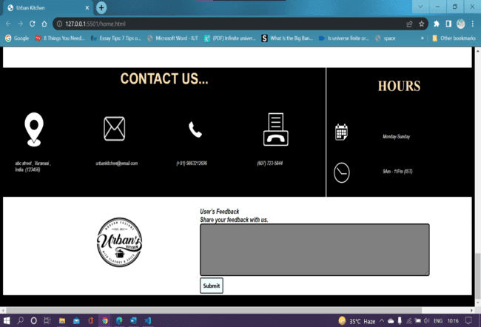
Home Page HTML
Code
<!DOCTYPE html>
<html lang="en">

<head>
<meta charset="UTF-8">
<meta http-equiv="X-UA-Compatible" content="IE=edge">
<meta name="viewport" content="width=device-width, initial-scale=1.0">
<title>Urban Kitchen</title>
<link rel="stylesheet" href="style_1.css">

</head>

<body>
<div class="header">
<img src="/img/lights.webp" alt="restaurant" style=" width: 100%; height: 300px; opacity: 40%;">
<div class="heading">
<h1>URBAN KITCHEN</h1>
</div>
<div class="para">

<p>live , love , eat</p>
</div>
<nav class="navbar">
<ul>
<li><a href=""> Home</a></li>
<li><a href="#about-us"> About</a></li>
<li><a href="menu.html"> Menu</a></li>
<li><a href="gallery.html"> Gallery</a> </li>
<li><a href="healthtips.html"> Health Tips</a> </li>
<li><a href="#contact-us"> Contact Us</a> </li>
</ul>
</nav>
</div>
<div class="container1">
<div class="container1_heading">
<h1>Welcome to our restaurant</h1>
</div>
<div class="container1_content">
<u>Our Specalities</u>
<ul>
<li>High quality and fresh food</li>
<li>Highly skilled chef who prepares meals using the finest, high-quality ingredients.</li>
<li>Along with Traditional dishes we bring unique and special dishes exclusively made by our chefs.</li>
<!-- <li>abc</li> -->
</ul>
</div>
<a href="#feedback"> <button class="btn">Feedback</button> </a>
</button>
</div>

<div class="container2" id="box2">
<h1>Dish of the Day</h1>
<div class="container2_img">

<img src="/img/Vegan-Palak-Tofu-7.jpg" alt="DISH">
</div>
<div class="container3">
<p><u> Palak Paneer</u></p>
<div class="aboutdish">
Palak paneer is a popular north Indian dish typically made with a spiced yet mild curry or gravy with
spinach (palak) and cubes of soft Indian cheese (paneer). The sauce often contains a bit of heavy cream
as well. It’s typically served with white basmati rice or an Indian flatbread, such as roti, or naan.
It’s flavorful, aromatic, and a good way to eat a lot of spinach.
</div>

</div>
</div>

<div class="gallery">
<div class="gallery-head">

Special Offers
</div>
<div class="gb1">
<div class="gallery-body">

<div class="image-box">
<img src="/img/Chicken-Biryani.jpg" alt="">
</div>
<div class="image-box">
<img src="/img/dosa.jpg" alt="">
</div>
<div class="image-box">
<img src="/img/palak-paneer.jpg" alt="">
</div>
<div class="image-box">
<img src="/img/pbm.jpg" alt="">
</div>

</div>
<div class="gallery-name">
<div class="name">Chicken-Biryani</div>
<div class="name">Dosa</div>
<div class="name">Palak Paneer</div>
<div class="name">Panner Butter Masala</div>
</div>
</div>

</div>

<div class="about-us" id="about-us">
<img src="/img/bg2..jpg" alt="">

<div class="au-content">

<div class="au-heading">
ABOUT US: <br> THE URBAN KITCHEN
</div>

<div class="au-body">

<div class="au-b-c1">
Craving some delicious Greek food? Maybe you’re in the mood for a juicy steak? No matter what kind
of meal you have in mind, The Urabn Kitchen is ready to prepare it for you. <br> <br>

Since 1973, The <i><b>Urban Kitchen</b></i> has been the go-to diner for residents of India. Our
diner serves breakfast all day, in addition to wholesome and flavorful dining options for lunch and
dinner. From burgers to salads, seafood to pastas, you’ll find all kinds of hearty meals prepared
fresh at The Urban Kitchen. Our diner also has a full bakery with delicious baked goods and other
treats, including our famous cheesecake. Sounds delicious, right?
<br> <br> <br>

We’re here to serve you the best food around, whenever you’re looking for a great Indian restaurant
.
</div>

</div>

</div>

</div>

<div class="extra1">
<div class="extra1-text">
<div class="extra1-heading">
Your Next Event... <br> <br>
</div>
<div class="extra1-body">
If you’ve never been to our restaurant before, you should know that it's a large dining room that can
seat many people. With that sort of space, we have the capacity to host a range of events and special
occasions. <br> <br>

The Urban Kitchen is happy to be the venue for your next presentation, reunion, party, luncheon or
banquet. With two banquet rooms, presentation screens, an LCD projector and a podium, The Spot
Restaurant can transform a space into the perfect site for your gathering.
<br> <br>
Whether you want to have your associates attend a training luncheon or you're planning a birthday party,
trust that we have the space, equipment and menu to accommodate any occasion. To reserve a space for
your next event, come by the restaurant or call (+91) 905XXXX today. <br> <br>
</div>
</div>
<div class="extra1-pic">
<img src="/img/extra1.jpg" alt="">
</div>
</div>

<div class="extra2">
<div class="extra2-text">
<div class="extra2-heading">
Stop in... <br> <br>
</div>
<div class="extra2-body">
To top it all off, The Urban Kitchen also has a full bar and a bakery. Whether you want to stop in for
an after work drink or a late night pastry, you’re sure to find what you’re looking for and a whole lot
more.
<br> <br>
At The Urban Kitchen, we want to get to know you and your friends in the Varnasi, India.
Hopefully you’ll come in and get to know us while enjoying our delicious food options.
<br> <br>
From beer to burgers, cheesecake to chops, we’re serving up what you're craving. Stop by our great
Inidan food diner in Varanasi, India, tonight.
<br> <br>
</div>
</div>
<div class="extra2-pic">
<img src="/img/extra2.jpg" alt="">
</div>
</div>
<div class="contactusmain" id="contact-us">
<div class="abc">

<div class="contact-us-head">
<h1>CONTACT US...</h1>
</div>

<div class="contact-us">
<div class="contact-us-box">
<img src="/img/location.jpg" alt=""> <br> <br>
<i>abc street , Varanasi , <br> India. (123456)</i>
</div>
<div class="contact-us-box">
<img src="/img/email.jpg" alt=""> <br> <br>
<i>urbankitchen@email.com</i>
</div>
<div class="contact-us-box">
<img src="/img/phone.jpg" alt=""><br> <br>
<i>(+91) 9863212696</i>
</div>
<div class="contact-us-box">
<img src="/img/fax.jpg" alt=""><br> <br>
<i>(607) 723-5844</i>
</div>

</div>
</div>
<div class="hours">
<div class="hours-heading">
<H1>HOURS</H1>
</div>
<div class="hours-body">
<img src="/img/calender.jpg" alt="">
<div class="hours-text">
<i> Monday-Sunday</i>
</div>
<img src="/img/clock.jpg" id="clock" alt="">
<div class="hours-text">
<i> 9Am - 11Pm (IST)</i>
</div>

</div>
</div>
</div>

<div class="end">
<img src="/img/logo-end.jpeg" alt="">
<div class="feedback" id="feedback">
<strong> <i> User's Feedback <br>
Share your feedback with us. <br>
</i>
</strong>

<textarea name="myText" id="feedback_text" cols="80" rows="7"></textarea>
<button class="btn" id="feedback_btn">Submit</button>
</div>
</div>

</body>

</html>

Home Page CSS Code

body {
background-color: #000000;
scroll-behavior: smooth;

}

@import url('https://fonts.googleapis.com/css2?family=Amatic+SC:wght@700&family=Open+Sans:wght@300&family=Ubuntu:wght@500&display=swap');
@import url('https://fonts.googleapis.com/css2?family=Amatic+SC:wght@700&family=Open+Sans:wght@300&family=Ubuntu:wght@500&display=swap');
@import url('https://fonts.googleapis.com/css2?family=Amatic+SC:wght@700&family=Comfortaa:wght@300;500&family=Lobster&family=Open+Sans:wght@300&family=Ubuntu:wght@500&display=swap');
@import url('https://fonts.googleapis.com/css2?family=Amatic+SC:wght@700&family=Comfortaa:wght@300;500&family=Lobster&family=Nanum+Myeongjo&family=Open+Sans:wght@300&family=Ubuntu:wght@500&display=swap');
@import url("https://fonts.googleapis.com/css2?family=Cinzel&display=swap");
@import url("https://fonts.googleapis.com/css2?family=BIZ+UDPMincho&family=Grape+Nuts&family=My+Soul&family=Square+Peg&display=swap");

.header {
position: left;
max-width: 100%;
/*Maximum width */

}

.heading {
position: absolute;
color: rgb(199 160 89);
font-size: 37px;
font-family: 'Cinzel', serif;
top: 20%;
left: 32%;
transform: translate(-50%, -50%);

}

.para {
position: absolute;
color: rgb(199 160 89);
font-family: 'Grape Nuts', cursive;
font-size: 50px;
top: 40%;
left: 44%;
transform: translate(-50%, -50%);
}

.navbar {

background-color: #ffffff;
border-radius: 4px;
}

.navbar ul {

overflow: auto;
}

.navbar li {
float: left;
list-style: none;
margin: 8px 70px;
}

.navbar li a {
/* padding: 2px 2px ; */
color: rgb(1, 1, 1);
text-decoration: none;
}

.navbar li a:hover {
color: rgb(88, 88, 87);
}

.container1 {
color: rgb(5, 5, 6);
display: inline-block;
width: 643px;
height: 315px;
border: 3px solid #8c928c;
margin: auto;
text-align: center;
background-color: rgb(208, 195, 195);
}

.container1_heading {
text-align: center;

text-decoration: underline;
margin-top: 40px;
}

.container1_content {
text-align: left;
margin-left: 5px;
margin-top: -15px;
font-size: 18px;
}

.btn {
font-family: 'Segoe UI', Tahoma, Geneva, Verdana, sans-serif;
font-weight: bold;
background-color: azure;
margin-top: 0px;
padding: 7px;
border: 2px solid rgb(40, 46, 46);
cursor: pointer;
font-size: 13px;
border-radius: 3px;
}

.btn:hover {
color: black;
background-color: rgb(127, 127, 127);
border: 2px solid black;
}

.container2 {
display: inline-block;
width: 48%;
border: 3px solid #8c928c;
position: relative;
top: -103px;
color: rgb(7, 7, 7);
text-align: center;
text-decoration: underline;
background-color: rgb(208, 195, 195);
}

.container2_img {
display: inline-block;
height: 200px;
width: 220px;
position: relative;
right: 15px;
top: -15px;
border: 2px solid rgb(144, 141, 141);
border-radius: 5px;
transition: 1s;
}
.container2_img:hover {
transform: scale(1.2);
z-index: 2;

}

#box2 {
float: left;
height: 315px;
width: 591px;
margin: -218px 655px;
}

img {

height: 200px;
width: 220px;

}

.container3 {
display: inline-block;
position: relative;
top: -13px;
left: 20px;
text-align: left;
/* padding: 0 60px; */
}
.aboutdish{
display: block;
/* border: 2px solid white; */
height: 149px;
width: 263px;
}
.specialoffers{
margin-top: 8px;
display: block;
border: 3px solid #8c928c;
background-color: rgb(1, 26, 49);
height: 200px;
}
.spoff_heading{

text-align: center;
color: white;
margin-top: 5px;
font-size: 18px;
text-decoration: underline;
/* border: 2px solid pink; */
}

.gallery-head{

display: flex;
/* border: 2px solid yellow; */
height: 100px;
width:100%;
justify-content: center;
align-items:center ;
line-height: 20px;
font-size: 30px;
color: white;

}
.gb1{
background-image: url(bg1.png);
background-size: 1252px 372px;
}
.gallery-body{
/* border: 2px solid yellow; */
display: flex;
margin: 2px auto;
flex-direction: row;
justify-content: center;
height: 320px;
width: 1252px;
align-items: center;

}
.image-box {

width: 250px;
border: 4px solid white;
border-radius: 8px;
margin: 0 10px;
box-shadow: 0 0 20px 2px rgba(0, 0, 0, .1);
transition: 1s;
}
.image-box:hover {

transform: scale(1.2);
z-index: 2;
}
.gallery-body img {
display: block;
height: 250px;
width: 100%;
border-radius: 6px;

}
.gallery-name{
color: white;
display: flex;
justify-content: space-around;
/* border: 2px solid yellow; */
height: 50px;
width: 100%;
}

.about-us{
height: 500px;
width: 100%;
/* border: 2px solid yellow; */
}
.about-us img{
height: 500px;
width: 100%;
opacity: 50%;
}
.au-content{
position: relative;
top: -480px;

}
.au-heading{
font-size: 30px;
font-family: 'Open Sans', sans-serif;
color: wheat;
text-align: center;
}
.au-body{
color: white;
padding: 30px;

}
.au-b-c1{
margin-left: 320px;
font-family: 'Lobster', cursive;
width: 47%;
}
.extra1{
/* border: 2px solid yellow; */
height: 450px;
width: 100%;
background: black;
}
.extra2{
/* border: 2px solid yellow; */
height: 400px;
width: 100%;
background: white;
}
.extra1-text{
color: white;
position: relative;
top: 50px;
left: 180px;
/* border: 2px solid pink; */
display: inline-block;
height: 200px;
width: 400px;
}
.extra2-text{
color: black;
position: relative;
top: 50px;
left: 700px;
/* border: 2px solid pink; */
display: inline-block;
height: 200px;
width: 400px;
}
.extra1-heading{
font-family: 'Ubuntu';
font-size: 30px;
color: red;

}
.extra2-heading{
font-family: 'Ubuntu';
font-size: 30px;
color: red;

}
.extra1-body{
color: white;
font-size: 14px
}
.extra2-body{
color: black;
font-size: 14px
}

.extra1-pic{
position: relative;
left: 400px;
top: -25px;
border: 2px solid white;
border-radius: 3px;
display: inline-block;
height: 200px;
width: 220px;
transition: 1s;
}
.extra1-pic:hover{
transform: scale(1.3);
}
.extra2-pic{
position: relative;
left: -180px;
top: 15px;
border: 2px solid black;
border-radius: 3px;
display: inline-block;
height: 200px;
width: 220px;
transition: 1s;
}

.extra2-pic:hover{
transform: scale(1.3);
}

.contactusmain{
width: 100%;
display: flex;
/* border: 2px solid green; */
flex-direction: row;
}
.contact-us-head{
font-family: 'Open Sans', sans-serif;
background: black;
/* border: 2px solid pink; */
height: 80px;
width: 100%;
color: wheat;
text-align: center;
}
.contact-us{

background: black;
/* border: 2px solid pink; */
height: 200px;
width: 100%;
display: flex;
justify-content: space-around;
}
.contact-us-box{
font-size: 12px;
font-family: 'Open Sans', 'Arial Narrow', Arial, sans-serif;
color: white;
display: inline-block;
background: black;
/* border: 2px solid pink; */
height: 100px;
width: 150px;

}
.contact-us-box img{

height: 100px;
width: 100px;

}
.abc{
position: relative;
top: -15px;
width: 100%;
}
.hours{
background-color: black;
display: inline-block;
width: 45%;
height: 285px;
border-left: 2px solid white;
}
.hours-heading{
/* border: 2px solid pink; */
height: 80px;
color: wheat;
text-align: center;

}
.hours-body{
font-size: 12px;
font-family: 'Open Sans', 'Arial Narrow', Arial, sans-serif;

color: white;
}
.hours-body img{
height: 80px;
width: 80px;
}
#clock{
padding-left: 10px;
height: 60px;
width: 60px;
}
.hours-text{
position: relative;
left: 150px;
top: -40px;
}

.end{
color: black;
position: relative;
top: -17px;
height: 216px;
background: white;
}
.end img{
position: relative;
left: 200px;
}

.feedback{
position: relative;
left: 300px;
font-family: 'Open Sans', 'Arial Narrow', Arial, sans-serif;
display: inline-block;
/* border: 2px solid pink; */
height: 100px;
width: 50%;

}
#feedback_text{
border: 2px solid black;
border-radius: 5px;
background: grey;
}

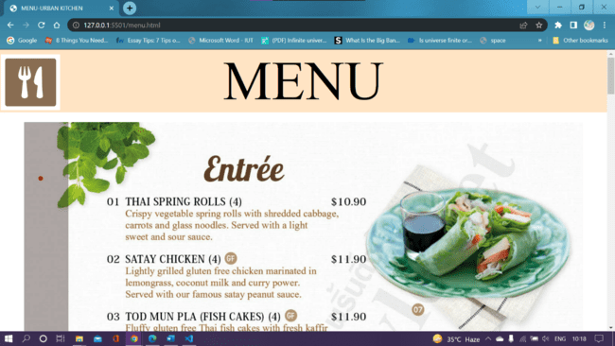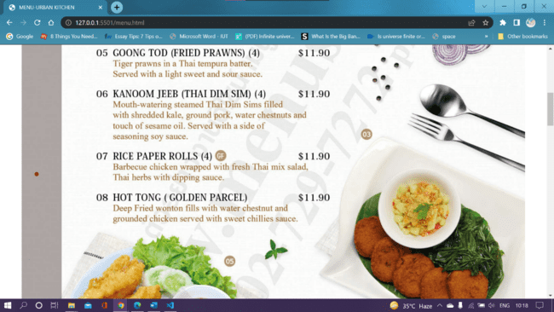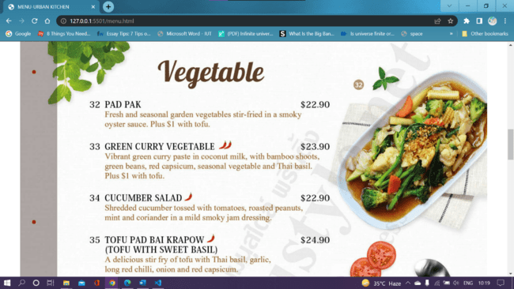
Menu Page HTML Code
<!DOCTYPE html>
<html lang="en">

<head>
<meta charset="UTF-8">
<meta http-equiv="X-UA-Compatible" content="IE=edge">
<meta name="viewport" content="width=device-width, initial-scale=1.0">
<title>MENU-URBAN KITCHEN</title>
<link rel="stylesheet" href="style_menu.css">
</head>

<body>
<div class="header">
<div class="left">
<img src="/img/menu.png" alt="">
</div>
<div class="title">
MENU
</div>
</div>
<div class="main">
<!-- <img src="/img/bgmenu.jpg" alt=""> -->
<div class="container">
<img src="/img/entreee.jpg" alt="">
<img src="/img/2.jpg" alt="">
<img src="/img/veg.jpg" alt="">
</div>
</div>
</body>

</html>

Menu Page CSS Code
body{
margin: 0px;
padding: 0px;

}
.header{
/* border: 2px solid yellow; */
text-align: center;
background-color: bisque;
}
.left{
display: inline-block;
position: absolute;
left: 2px;
top: 10px;
}
.left img{
height: 116px;
width: 123px;
}
.title{
/* border: 2px solid red; */
display: inline-block;
font-size: 114px;
}
.main img{
width: 100%;
display: fixed;

}
.container{
display: flex;
flex-direction: column;
justify-content: center;
margin: 20px 50px;
}

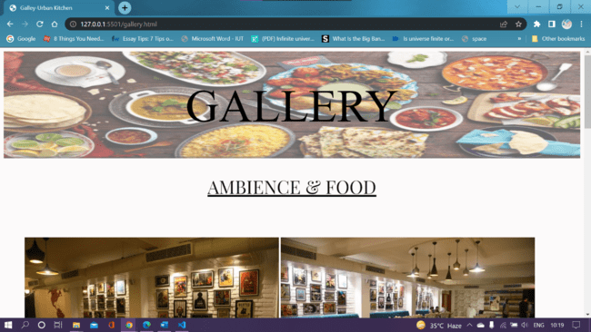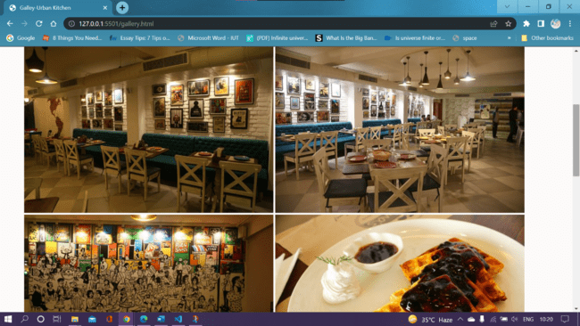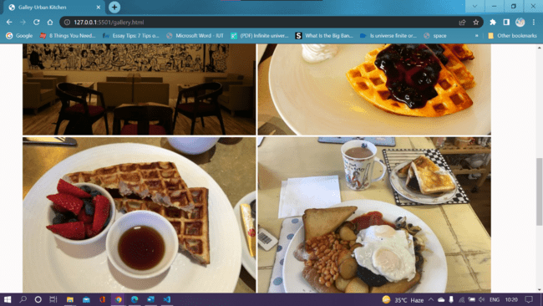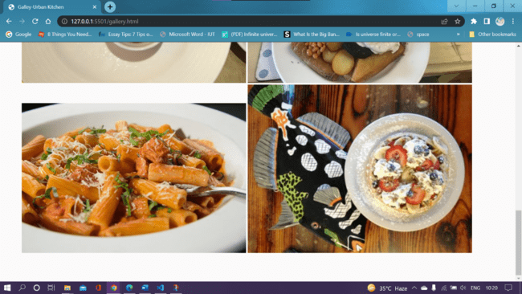

Gallery Page HTML Code
<!DOCTYPE html>
<html lang="en">
<head>
<meta charset="UTF-8">
<meta http-equiv="X-UA-Compatible" content="IE=edge">
<meta name="viewport" content="width=device-width, initial-scale=1.0">
<title>Galley-Urban Kitchen</title>
<link rel="stylesheet" href="style_gallery.css">
<link href="https://fonts.googleapis.com/css2?family=Indie+Flower&family=Playfair+Display&display=swap" rel="stylesheet">
</head>
<body>
<div class="header">
<img src="/img/Indian-food-1.jpg" alt="">
<div class="heading">
GALLERY
</div>
</div>
<div class="mid">
AMBIENCE & FOOD
</div>
<div class="photogrid">
<div class="images">
<img src="/img/img1.jpg" alt="">
<img src="/img/img4.jpg" alt="">
<img src="/img/img5.jpg" alt="">
<img src="/img/img7.jpg" alt="">
<img src="/img/img8.jpg" alt="">
<img src="/img/img9.jpg" alt="">
<img src="/img/img10.jpg" alt="">
<img src="/img/img11.jpg" alt="">
</div>
</div>
</body>
</html>

Gallery Page CSS Code
body{
background-color: rgb(252, 250, 250);
/* opacity: 20%; */
}
.header{
position: relative;
/* border: 2px solid rgb(10, 7, 7); */
text-align: center;

}
.header img{
height: 232px;
width: 100%;
opacity: 60%;
}
.heading{
position: absolute;
top: 50%;
left: 50%;
transform: translate(-50%, -50%);
font-size: 100px;
/* font-family:'Indie Flower', cursive; */
color: #000000;;

}
.mid{
/* border: 2px solid rgb(230, 216, 216); */
display:block;
/* right: 50px;
top: 10px; */
font-family: 'Playfair Display', serif;
text-align: center;
color: rgb(13, 13, 13);
height: 40px;
font-size: 40px;
padding: 30px 20px;
text-decoration: underline;
}
.photogrid{
margin: 22px 0px;
/* border: 2px solid red; */
display: flex;
flex-wrap: wrap;
justify-content: center;
}
.images{
padding: 25px;
margin: 20px;
margin-right: 20px;
}
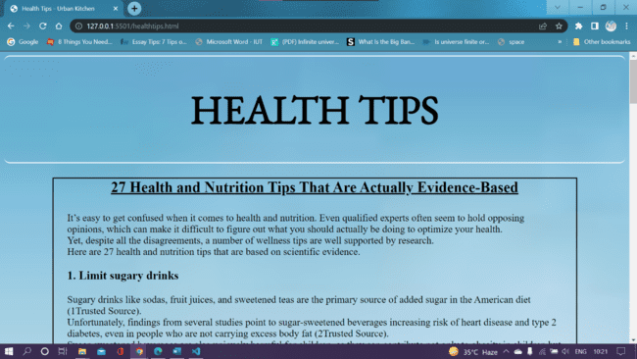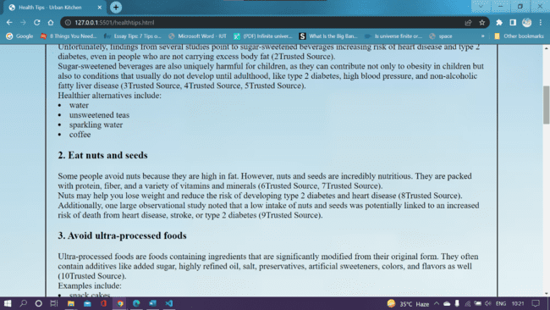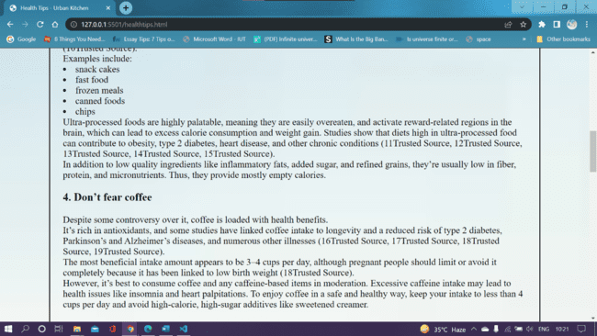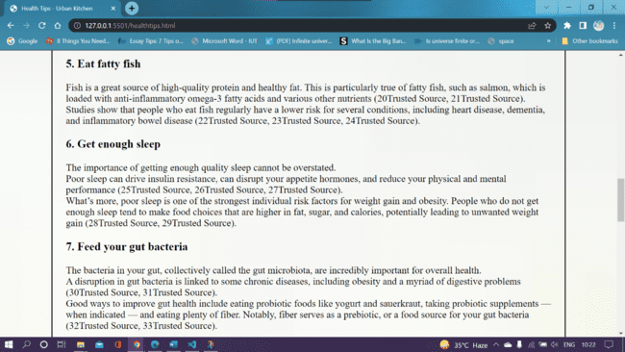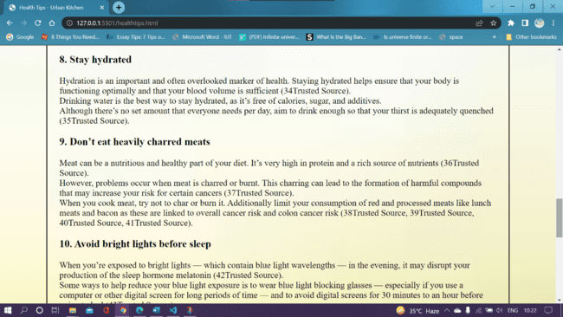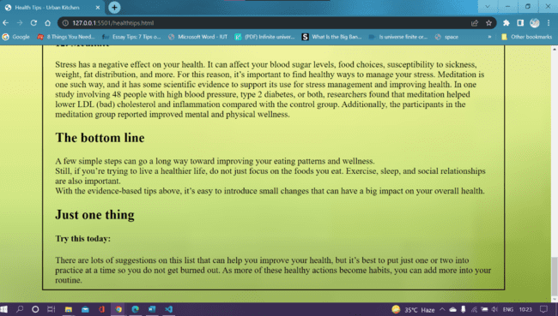

Health Tips HTML Code
<!DOCTYPE html>
<html lang="en">
<head>
<meta charset="UTF-8">
<meta http-equiv="X-UA-Compatible" content="IE=edge">
<meta name="viewport" content="width=device-width, initial-scale=1.0">
<title>Health Tips - Urban Kitchen </title>
<link rel="stylesheet" href="style_healthtips.css">
<link href="https://fonts.googleapis.com/css2?family=EB+Garamond&display=swap" rel="stylesheet">
</head>
<body>
<div class="heading">
<h1>HEALTH TIPS</h1>

</div>
<div class="box_left">

<div class="topic"> 27 Health and Nutrition Tips That Are Actually Evidence-Based</div>
<br>
<div class="content">
It’s easy to get confused when it comes to health and nutrition. Even qualified experts often seem to hold opposing opinions, which can make it difficult to figure out what you should actually be doing to optimize your health.
<br>
Yet, despite all the disagreements, a number of wellness tips are well supported by research.
<br>
Here are 27 health and nutrition tips that are based on scientific evidence.
<br>

<h3> 1. Limit sugary drinks</h3>
Sugary drinks like sodas, fruit juices, and sweetened teas are the primary source of added sugar in the American diet (1Trusted Source).
<br>
Unfortunately, findings from several studies point to sugar-sweetened beverages increasing risk of heart disease and type 2 diabetes, even in people who are not carrying excess body fat (2Trusted Source).
<br>
Sugar-sweetened beverages are also uniquely harmful for children, as they can contribute not only to obesity in children but also to conditions that usually do not develop until adulthood, like type 2 diabetes, high blood pressure, and non-alcoholic fatty liver disease (3Trusted Source, 4Trusted Source, 5Trusted Source).
<br>
Healthier alternatives include:

<li>water</li>
<li>unsweetened teas</li>
<li>sparkling water</li>
<li>coffee</li>

<h3>2. Eat nuts and seeds</h3>
Some people avoid nuts because they are high in fat. However, nuts and seeds are incredibly nutritious. They are packed with protein, fiber, and a variety of vitamins and minerals (6Trusted Source, 7Trusted Source).
<br>
Nuts may help you lose weight and reduce the risk of developing type 2 diabetes and heart disease (8Trusted Source).
<br>
Additionally, one large observational study noted that a low intake of nuts and seeds was potentially linked to an increased risk of death from heart disease, stroke, or type 2 diabetes (9Trusted Source).
<br>

<h3>3. Avoid ultra-processed foods</h3>
Ultra-processed foods are foods containing ingredients that are significantly modified from their original form. They often contain additives like added sugar, highly refined oil, salt, preservatives, artificial sweeteners, colors, and flavors as well (10Trusted Source).
<br>
Examples include:

<li> snack cakes</li>
<li> fast food</li>
<li> frozen meals</li>
<li>canned foods</li>
<li> chips</li>
Ultra-processed foods are highly palatable, meaning they are easily overeaten, and activate reward-related regions in the brain, which can lead to excess calorie consumption and weight gain. Studies show that diets high in ultra-processed food can contribute to obesity, type 2 diabetes, heart disease, and other chronic conditions (11Trusted Source, 12Trusted Source, 13Trusted Source, 14Trusted Source, 15Trusted Source).
<br>
In addition to low quality ingredients like inflammatory fats, added sugar, and refined grains, they’re usually low in fiber, protein, and micronutrients. Thus, they provide mostly empty calories.
<br>
<h3>4. Don’t fear coffee</h3>
Despite some controversy over it, coffee is loaded with health benefits.
<br>
It’s rich in antioxidants, and some studies have linked coffee intake to longevity and a reduced risk of type 2 diabetes, Parkinson’s and Alzheimer’s diseases, and numerous other illnesses (16Trusted Source, 17Trusted Source, 18Trusted Source, 19Trusted Source).
<br>
The most beneficial intake amount appears to be 3–4 cups per day, although pregnant people should limit or avoid it completely because it has been linked to low birth weight (18Trusted Source).
<br>
However, it’s best to consume coffee and any caffeine-based items in moderation. Excessive caffeine intake may lead to health issues like insomnia and heart palpitations. To enjoy coffee in a safe and healthy way, keep your intake to less than 4 cups per day and avoid high-calorie, high-sugar additives like sweetened creamer.
<br>
<h3>5. Eat fatty fish</h3>
Fish is a great source of high-quality protein and healthy fat. This is particularly true of fatty fish, such as salmon, which is loaded with anti-inflammatory omega-3 fatty acids and various other nutrients (20Trusted Source, 21Trusted Source).
<br>
Studies show that people who eat fish regularly have a lower risk for several conditions, including heart disease, dementia, and inflammatory bowel disease (22Trusted Source, 23Trusted Source, 24Trusted Source).
<br>

<h3>6. Get enough sleep</h3>
The importance of getting enough quality sleep cannot be overstated.
<br>
Poor sleep can drive insulin resistance, can disrupt your appetite hormones, and reduce your physical and mental performance (25Trusted Source, 26Trusted Source, 27Trusted Source).
<br>
What’s more, poor sleep is one of the strongest individual risk factors for weight gain and obesity. People who do not get enough sleep tend to make food choices that are higher in fat, sugar, and calories, potentially leading to unwanted weight gain (28Trusted Source, 29Trusted Source).
<br>
<h3>7. Feed your gut bacteria</h3>
The bacteria in your gut, collectively called the gut microbiota, are incredibly important for overall health.
<br>
A disruption in gut bacteria is linked to some chronic diseases, including obesity and a myriad of digestive problems (30Trusted Source, 31Trusted Source).
<br>
Good ways to improve gut health include eating probiotic foods like yogurt and sauerkraut, taking probiotic supplements — when indicated — and eating plenty of fiber. Notably, fiber serves as a prebiotic, or a food source for your gut bacteria (32Trusted Source, 33Trusted Source).
<br>

<h3>8. Stay hydrated</h3>
Hydration is an important and often overlooked marker of health. Staying hydrated helps ensure that your body is functioning optimally and that your blood volume is sufficient (34Trusted Source).
<br>
Drinking water is the best way to stay hydrated, as it’s free of calories, sugar, and additives.
<br>
Although there’s no set amount that everyone needs per day, aim to drink enough so that your thirst is adequately quenched (35Trusted Source).
<br>
<h3> 9. Don’t eat heavily charred meats</h3>
Meat can be a nutritious and healthy part of your diet. It’s very high in protein and a rich source of nutrients (36Trusted Source).
<br>
However, problems occur when meat is charred or burnt. This charring can lead to the formation of harmful compounds that may increase your risk for certain cancers (37Trusted Source).
<br>
When you cook meat, try not to char or burn it. Additionally limit your consumption of red and processed meats like lunch meats and bacon as these are linked to overall cancer risk and colon cancer risk (38Trusted Source, 39Trusted Source, 40Trusted Source, 41Trusted Source).
<br>
<h3> 10. Avoid bright lights before sleep</h3>
When you’re exposed to bright lights — which contain blue light wavelengths — in the evening, it may disrupt your production of the sleep hormone melatonin (42Trusted Source).
<br>
Some ways to help reduce your blue light exposure is to wear blue light blocking glasses — especially if you use a computer or other digital screen for long periods of time — and to avoid digital screens for 30 minutes to an hour before going to bed (43Trusted Source).
<br>

This can help your body better produce melatonin naturally as evening progresses, helping you sleep better.

<h3> 11. Take vitamin D if you’re deficient</h3>
Most people do not get enough vitamin D. While these widespread vitamin D inadequacies are not imminently harmful, maintaining adequate vitamin D levels can help to optimize your health by improving bone strength, reducing symptoms of depression, strengthening your immune system, and lowering your risk for cancer (44Trusted Source, 45Trusted Source, 46Trusted Source, 47Trusted Source).
<br>
If you do not spend a lot of time in the sunlight, your vitamin D levels may be low.
<br>
If you have access, it’s a great idea to have your levels tested, so that you can correct your levels through vitamin D supplementation if necessary.

<h3>12. Meditate</h3>
Stress has a negative effect on your health. It can affect your blood sugar levels, food choices, susceptibility to sickness, weight, fat distribution, and more. For this reason, it’s important to find healthy ways to manage your stress.

Meditation is one such way, and it has some scientific evidence to support its use for stress management and improving health.

In one study involving 48 people with high blood pressure, type 2 diabetes, or both, researchers found that meditation helped lower LDL (bad) cholesterol and inflammation compared with the control group. Additionally, the participants in the meditation group reported improved mental and physical wellness.

<h2>The bottom line</h2>
A few simple steps can go a long way toward improving your eating patterns and wellness.
<br>
Still, if you’re trying to live a healthier life, do not just focus on the foods you eat. Exercise, sleep, and social relationships are also important.
<br>
With the evidence-based tips above, it’s easy to introduce small changes that can have a big impact on your overall health.

<h2>Just one thing</h2>
<h4>Try this today:</h4> There are lots of suggestions on this list that can help you improve your health, but it’s best to put just one or two into practice at a time so you do not get burned out. As more of these healthy actions become habits, you can add more into your routine.
</div>
</div>
</div>

</body>
</html>

Health Tips CSS Code

body{
background-color: rgb(240, 237, 233);
background-image:url(/img/download.jpg);
background-repeat: no-repeat;
background-position: center;
background-size: cover;
}
.heading{
border: 2px solid rgb(255, 255, 255);
text-align: center;
font-size: 40px;
border-radius: 12px;
border-left: 0px;
border-right: 0px;
font-family: 'EB Garamond', serif;

}
.box_left
{
border: 2px solid rgb(12, 5, 5);
margin: 29px 97px;
font-size: 20px;
/* width: 880px; */

}
.box h2{
text-align: center;
}
.topic{
text-align: center;
text-decoration: underline;
font-size: 30px;
font-weight: bold;
}
.content{
margin: 10px 28px;
}

THANK
YOU

